**ORDER BY, GROUP BY AND HAVING CLAUSE**

CREATE TABLE CUSTOMER_EXP08_CSA_41 (CUSTOMERID INT PRIMARY KEY, CUSTOMERNAME VARCHAR(100), CONTACTNO VARCHAR(20), ADDRESS VARCHAR(255), CITY VARCHAR(100), POSTALCODE VARCHAR(10), COUNTRY VARCHAR(50));

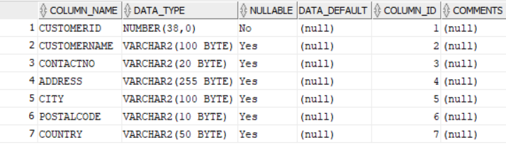

CREATE TABLE EMPLOYEES_EXP08_CSA_41 (EMPLOYEEID INT PRIMARY KEY, LASTNAME VARCHAR(100), FIRSTNAME VARCHAR(100), BIRTHDATE DATE, PHOTO VARCHAR(10));

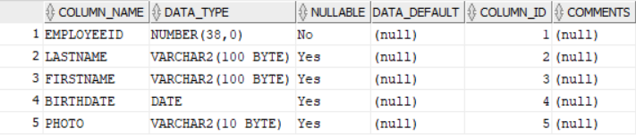

CREATE TABLE ORDERS_EXP08_CSA_41 (ORDERID INT PRIMARY KEY, CUSTOMERID INT, EMPLOYEEID INT, ORDERDATE DATE, SHIPPERID INT, FOREIGN KEY (CUSTOMERID) REFERENCES CUSTOMER_EXP08_CSA_41(CUSTOMERID), FOREIGN KEY (EMPLOYEEID) REFERENCES EMPLOYEES_EXP08_CSA_41(EMPLOYEEID));

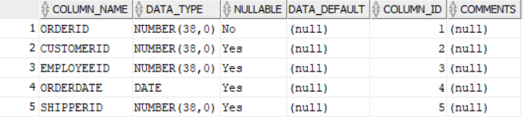

INSERT INTO Customer_Exp08_CSA_41 VALUES (1, 'John', '123456789', '123 Elm St', 'New York', '10001', 'USA');

INSERT INTO Customer_Exp08_CSA_41 VALUES (2, 'Jibin', '987654321', '456 Oak St', 'Los Angeles', '90001', 'USA');

INSERT INTO Customer_Exp08_CSA_41 VALUES (3, 'Nagaraj', '555555555', '789 Pine St', 'Chicago', '60601', 'USA');

INSERT INTO Customer_Exp08_CSA_41 VALUES (4, 'Pranav', '444444444', '321 Cedar St', 'Houston', '77001', 'USA');

INSERT INTO Customer_Exp08_CSA_41 VALUES (5, 'Felix', '333333333', '654 Maple St', 'Toronto', '68560', 'Canada');

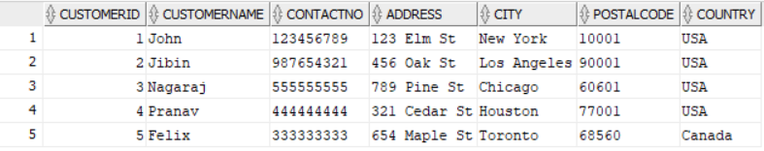

INSERT INTO Employees_Exp08_CSA_41 VALUES (1, 'Jeswin', 'Sabu', TO_DATE('1978-03-01', 'YYYY-MM-DD'), NULL);

INSERT INTO Employees_Exp08_CSA_41 VALUES (2, 'Jose', 'Thomas', TO_DATE('1985-07-22', 'YYYY-MM-DD'), NULL);

INSERT INTO Employees_Exp08_CSA_41 VALUES (3, 'Kevin', 'Biju', TO_DATE('1990-12-15', 'YYYY-MM-DD'), NULL);

INSERT INTO Employees_Exp08_CSA_41 VALUES (4, 'Lidiya', 'Reju', TO_DATE('1982-11-05', 'YYYY-MM-DD'), NULL);

INSERT INTO Employees_Exp08_CSA_41 VALUES (5, 'Maria', 'Alex', TO_DATE('1975-02-10', 'YYYY-MM-DD'), NULL);

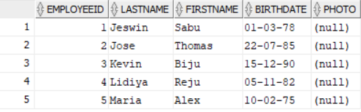

INSERT INTO Orders_Exp08_CSA_41 VALUES (1, 1, 1, TO_DATE('2023-09-01', 'YYYY-MM-DD'), 1);

INSERT INTO Orders_Exp08_CSA_41 VALUES (2, 2, 2, TO_DATE('2023-08-15', 'YYYY-MM-DD'), 2);

INSERT INTO Orders_Exp08_CSA_41 VALUES (3, 3, 3, TO_DATE('2023-07-20', 'YYYY-MM-DD'), 3);

INSERT INTO Orders_Exp08_CSA_41 VALUES (4, 4, 4, TO_DATE('2023-06-30', 'YYYY-MM-DD'), 4);

INSERT INTO Orders_Exp08_CSA_41 VALUES (5, 1, 5, TO_DATE('2023-05-10', 'YYYY-MM-DD'), 5);

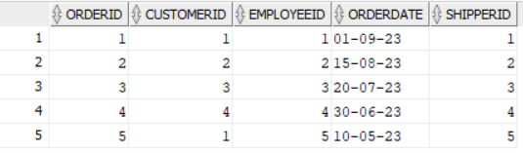

SELECT * FROM Customer_Exp08_CSA_41 ORDER BY CustomerName ASC;

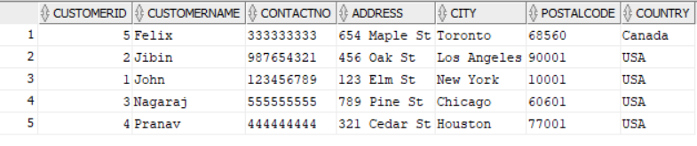

SELECT * FROM Orders_Exp08_CSA_41 ORDER BY OrderDate ASC;

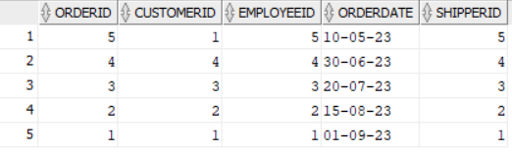

SELECT * FROM Employees_Exp08_CSA_41 WHERE BirthDate > TO_DATE('1980-01-01', 'YYYY-MM-DD') ORDER BY BirthDate DESC;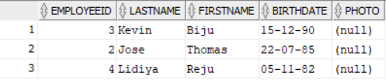

SELECT O.* FROM Orders_Exp08_CSA_41 O JOIN Customer_Exp08_CSA_41 C ON O.CustomerID = C.CustomerID WHERE C.Country = 'USA' ORDER BY O.OrderDate DESC;

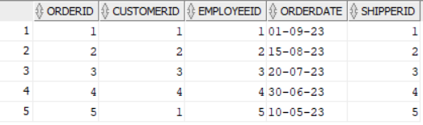

SELECT C.CustomerName, COUNT(O.OrderID) AS TotalOrders FROM Customer_Exp08_CSA_41 CJOIN Orders_Exp08_CSA_41 O ON C.CustomerID = O.CustomerID GROUP BY C.CustomerName;

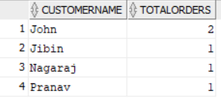

SELECT City, COUNT(CustomerID) AS TotalCustomers FROM Customer_Exp08_CSA_41 GROUP BY City;

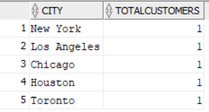

SELECT C.CustomerName, COUNT(O.OrderID) AS TotalOrders FROM Customer_Exp08_CSA_41 C JOIN Orders_Exp08_CSA_41 O ON C.CustomerID = O.CustomerID GROUP BY C.CustomerName HAVING COUNT(O.OrderID) > 2;

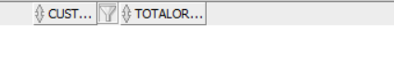

SELECT City, COUNT(CustomerID) AS TotalCustomers FROM Customer_Exp08_CSA_41 GROUP BY City HAVING COUNT(CustomerID) > 3;

